Shipboard Maintenance and Logistics Concept of Operations
The purpose of this concept of operations is to define a problem space that requires a solution based on the overarching project objectives and architectural tenets as specified below.
- Objective:
  - Define a cloud based component architecture using J2EE COTS framework that will demonstrate a multi-tiered approach to defining and deploying web services. The resultant solution should have the ability to drive multiple presentation devices (i.e. web browser, mobile, stand-alone).
- Architectural Tenets: (Demonstrate)
  - Ability to swap out database technologies without affecting business logic
  - Heavy and light-weight web service approaches
  - Realizes SOA principles
  - Decoupling of the user interface look/feel from data
  - Asynchronous messaging
    - Within the context of both the cloud based solution as well as driving content to client devices
  - Ability to deploy solution on multiple application servers
  - User authentication/security
  - Cloud based solution should be able to drive multiple presentation devices:
    - Browser, mobile (android, IOS), client application
Problem Space:
Develop a web based Shipboard Maintenance and Logistics System (SMLS) to provide an integrated Conditioned Based Maintenance (CBM) solution to shipboard maintenance personnel. Condition-Based Maintenance (CBM) is a maintenance philosophy used by industry to actively manage the health condition of assets in order to perform maintenance when it is needed and at the most opportune times. CBM components are an optimized mix of maintenance technologies (diagnostics and prognostics) – detection algorithms alert users to potential problems and unknown failures, diagnostic algorithms isolate failures to specific components or subsystems, prognostic algorithms estimate remaining useful life, and reasoning algorithms reconcile information and provide recommendations.

Figure 1. represents a notional sub-system architecture for the SMLS that includes actors as well as interaction with existing external systems. The following sections provide a high level description of each external system, their exported services, and information exchange requirements. Refer to the SMLS user stories for SMLS requirements.
A browser based presentation shall be supported for this project using the Ozone Widget Framework, an open source framework for visually organizing and laying out light weight web applications (widgets) within a user’s browser (https://www.owfgoss.org)
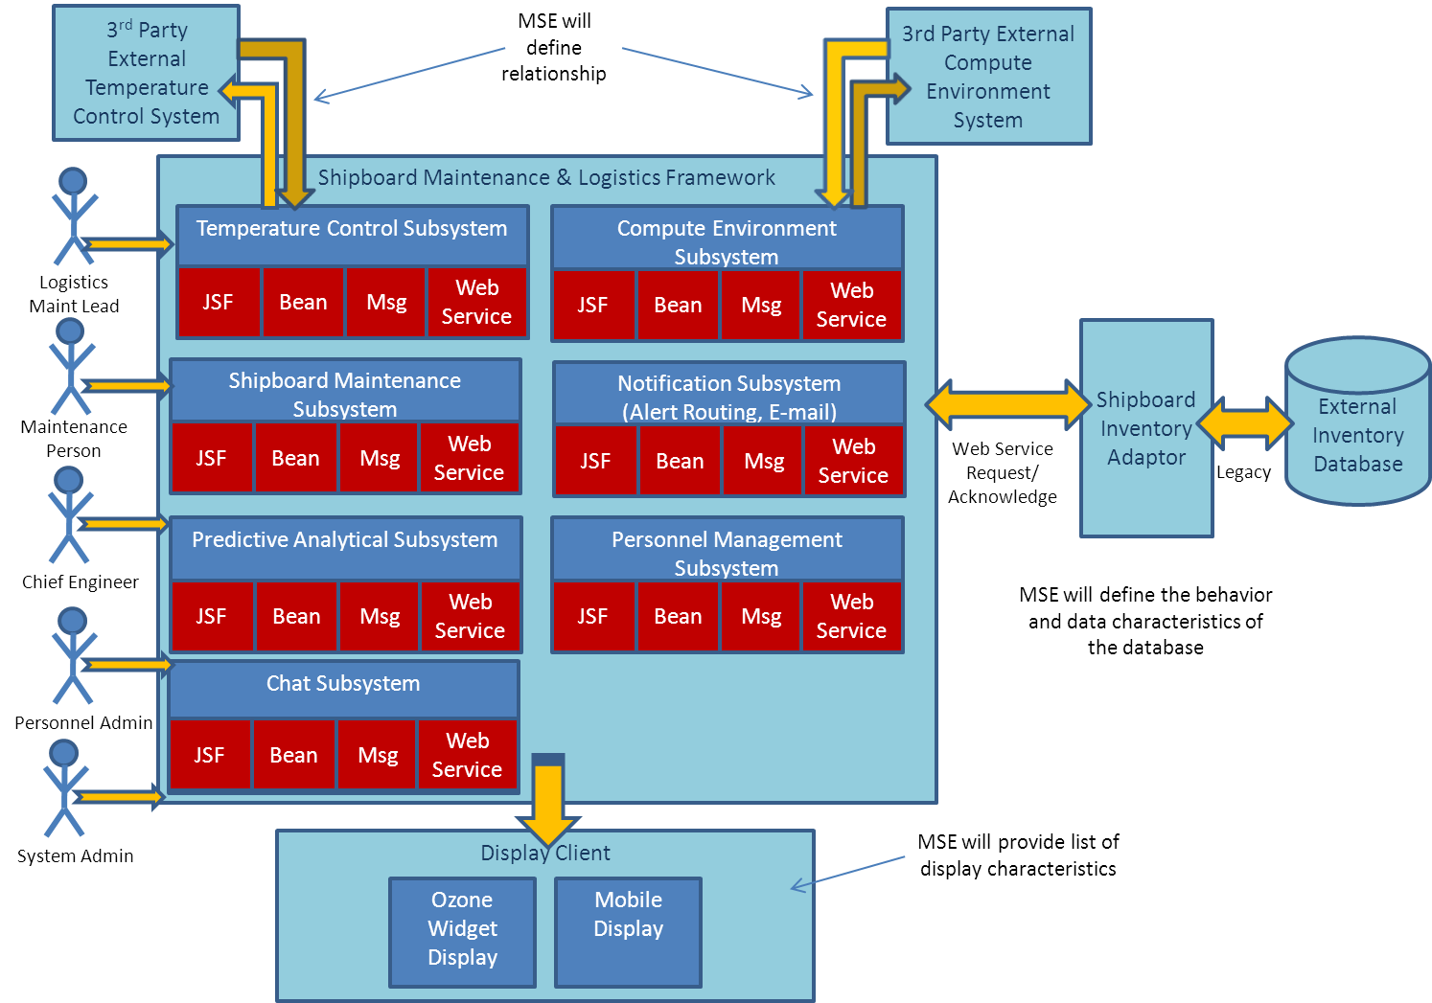
Figure 1. SMLS Architecture
External Compute Environment Monitoring System
The Shipboard Maintenance and Logistics System (SMLS) will interact with the External Compute Environment Monitoring System (ECEMS). This system is provided by a third party vendor and monitors critical environmental conditions, such as cabinet temperature, humidity, liquid water presence, and cabinet power supply. These sensors are connected to a reporting controller device in each compute cabinet. In addition to these cabinet based environmental conditions, the reporting controller device includes Ethernet connections for up to 8 rack mounted blade computers (BC). These connections allow each BC to report the following: fan speed, BC temperature, and power level. A reporting controller device will exist for each computer cabinet and the data collected by each reporting controller device is forwarded to the ECEMS management console where the information is retained by cabinet ID for use by the SMLS.
For purposes of simplicity, we will assume that the ECEMS management console provides the IT installers the ability to provide a unique ID, name, and location for each cabinet. All cabinet based environment sensors and the 1-8 BCs will be associated with the unique cabinet ID. In addition, the individual reporting controller devices will have the ability to identify each of the BCs by hostname and BC ID. Each individual environmental sensor will have the ability to perform self-diagnostics and provide its own operational status (Up/Down/Self-Test) as commanded by each reporting controller device. Each sensor will have a part ID which can be used to support maintenance task order creation and parts inventory queries as well as a unique sensor ID.
The ECEMS provides users of their system a web services interface to support status reporting from the ECEMS as well as command requests from the SMLS. The ECEMS can support both WSDL and Restful web services interfaces. Demonstrate one of these approaches for this external service interface.
ECEMS Exported Service Interfaces
- Provide interface to request compute environment status for all cabinets.
- Provide interface to request all compute environment status by cabinet ID

ECEMS Exported Services Data
Cabinet Info | Units | Sensor Status
- Cabinet ID | String
- Cabinet Name | String
- Cabinet Location | String
- Cabinet Status | String | Up/Down/Degraded
Cabinet Sensors
- Temperature Sensor  - Temperature  - ID  - Name  - Part # | Degrees Fahrenheit  String  String  String | Up/Down/Self-Test
- Humidity Sensor  - Relative Humidity  - ID/Name/Part# as defined for Temperature Sensor | String  0-100% | Up/Down/Self-Test
- Liquid Sensor  - Liquid Detection  - ID/Name/Part# as defined for Temperature Sensor | String  Boolean (True/False) | Up/Down/Self-Test
- Power Supply Sensor  - Voltage  - Frequency  - ID/Name/Part# as defined for Temperature Sensor | String  Voltage AC  Hz | Up/Down/Self-Test
BC Status (1-8) Within Cabinet
- BC Status | String | Up/Down/Degraded
- Hostname | String
- BC ID | String
- BC Part# | String
- Fan Speed | RPM | Up/Down/Self-Test
- Temperature | Degrees Fahrenheit | Up/Down/Self-Test
- Power Supply | Voltage (VAC), Frequency (Hz) | Up/Down/Self-Test

External Inventory Database System
The Shipboard Maintenance and Logistics System (SMLS) will interact with an external legacy system that houses the ships parts inventory database. This system retains information related to maintenance parts utilized on the ship. It is maintained by an inventory specialist via its own dedicated console. It is standalone in that it does not directly interface with any other system. It does, however, provide an internal “proprietary” non-web service based interface that supports interaction with the console. When a maintenance person needs a part for their work order, they currently need to work directly with the inventory specialist to query part availability, reserve part or order more.
To facilitate integration with the SMLS, a Shipboard Inventory Adaptor (SIA) will need to be developed that will interact with the “proprietary” internal interface of the legacy database system on one side and provide an “open” interface on the other. The SMLS will interact with the “open” interface to allow for automatic injection of inventory data into the system. It will also allow maintenance persons that need parts the ability to request parts be ordered via the SMLS. When a maintenance person is assigned a work order, they can reserve parts needed for the job prior to actually retrieving it from the inventory specialist. This will also be done via the interface of the SIA to the database system
For purposes of simplicity, we will assume that the inventory specialist enters all information related to parts, such as part number, description and inventory counts, directly into the legacy database system via the legacy dedicated console. Any new parts to the system will also only be entered into the database via the inventory specialist, not by the SMLS. The SIA interface to the database system will only support the request of part information, reservation of parts and the ordering of parts.
The SIA provides users of that system a web services interface to support inventory statuses as well as requests from the SMLS. The SIA can support both WSDL and Restful web services interfaces. Demonstrate one of these approaches for this external service interface.
Legacy Database System Proxy Exported Service Interfaces
- Provide interface to SMLS to provide inventory information by part or by part grouping
- Provide interface to support part reservation and part ordering requests by the SMLS

Legacy Database System Proxy Exported Services Data
Part Record | Units
- Part Number | String
- Part Description | String
- Unique ID | String
- Group ID | String
- Group Description | String
- Inventory Count | Integer
- Part Location | String

Reserved Part Table | Units
- Reserved | Array of Part Records

External Temperature Control System
The Shipboard Maintenance and Logistics System (SMLS) will interact with the External Temperature Control System (ETCS). This system is provided by a third party vendor and monitors temperature status of particular shipboard components for instances where temperatures are suddenly outside of their designated thresholds. Thermostats continuously report temperatures directly to the external temperature control system. For purposes of simplicity, we will assume that the ETCS management console provides the IT installers the ability to provide a unique ID, location and part number for each thermostat. Each individual temperature sensor will have the ability to perform self-diagnostics and provide its own operational status (Up/Down/Self-Test) as commanded by each reporting controller device.
The ETCS provides users of their system a web services interface to support status reporting from the ETCS as well as command requests from the SMLS. The ETSC can support both WSDL and Restful web services interfaces. Demonstrate one of these approaches for this external service interface.
ETSC Exported Service Interfaces
- Provide interface to view the status for all temperature sensors.
- Provide interface to request temperature sensor data by sensor ID
- Provide interface to view the temperatures based on location and zone.
- Provide command interface to change thermostat temperature setting by sensor ID or location.

ETCS Exported Services Data
Temperature Sensor ID | Shipboard Location |  | Sensor Status
- TS001 | Crew | Zone 1 | Up/Down/Self-Test
- TS002 | Crew | Zone 2 | Up/Down/Self-Test
- TS003 | Deckhouse | Zone 1 | Up/Down/Self-Test
- TS004 | Deckhouse | Zone 2 | Up/Down/Self-Test
- TS005 | Chilled Water System |  | Up/Down/Self-Test
- TS006 | HVAC |  | Up/Down/Self-Test
- … | Engine | Zone 1 | Up/Down/Self-Test
- TS0NN | Engine | Zone 2 | Up/Down/Self-Test

